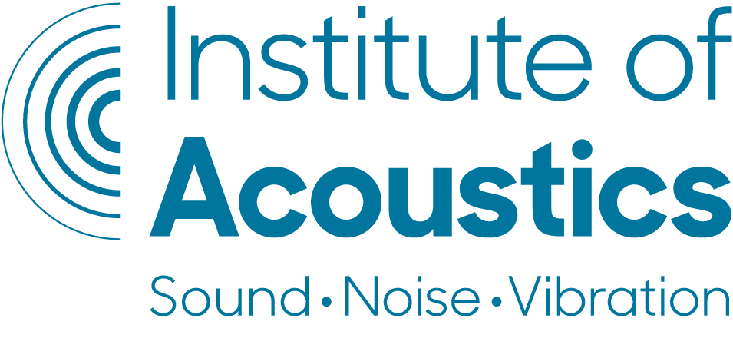

Medals and Awards

Nomination Form

Name of Award:

Please note: As this form is to be photocopied, answers should be written/typed in black ink.

Full name of candidate:

Address of candidate:
(for future correspondence)

E-mail:

Date of birth of candidate:

Academic and/or professional qualifications, career and current appointment

A description (in no less than 500 words) of the candidate’s major contributions to acoustics in relation to the purpose of the Award.

Statement by the proposer of the reasons why the candidate is worthy of receiving the Award.

Name and address of person who will prepare the citation/encomium.

Names and addresses of two referees who could be consulted (whose agreement to act as such have been obtained before submitting the proposal).

1)

2)

Name and address of proposer.

Date: | Signature of proposer:

Please note: Personal data provided on this form may be held and processed on the Institute's computer system.

Please email nomination form to: allan.chesney@ioa.org.uk

Postal address:
The President, The Institute of Acoustics, Silbury Court, 406 Silbury Boulevard, Milton Keynes, MK9 2AF

